**"A STUDY ON THE RELATIONSHIP BETWEEN UNEMPLOYMENT AND MENTAL HEALTH "**

**A project submitted to**



**University of Mumbai for partial completion of the degree of Master of Arts (Economics) under the Faculty of Arts**

**BY**

**Rinky Ramsingh Yadav**

**Under The Guidance of**

**PROF.SOMNATH VIBHUTE**

**ST. GONSALO GARCIA COLLEGE**

**VASAI(West)**

**2024-2025**

**CERTIFICATE**

This is to certify that **RINKY RAMSINGH YADAV** of **MASTER OF ARTS** Semester IV (2024-2025) has successfully completed the project on the topic **A Study on the relationship between unemployment and mental health** under the guidance of **Prof.SOMNATH VIBHUTE**

**_____________________**

**PRINCIPAL**

**(Dr.Somnath Vibhute)**

**____________________**

**EXTERNAL EXAMINER**

**ACKNOWLEDGEMENT**

I would like to acknowledge the following as idealistic channels and fresh dimensions in completing this project.

I take this opportunity to thank the **University of Mumbai** for giving me the chance to do this project.

I would like to thank my **Principal, Dr. Somnath Vibhute,** for providing the necessary facilities required for completion of this project.

I would like to thank my **College Library** for providing various reference books and magazines related to my project.

Lastly, I would like to thank each and every person who directly or indirectly helped me complete the project, especially my parents and peerswho supported me throughout my project.

**DECLARATION**

I undersigned **Miss Rinky Ramsingh Yadav** here by, declare that the work embodied in this project work title "**A Study on the Relationship between unemployment and mental health"** forms my contribution to the research work carried out under the guidance of **Prof. Somnath Vibhute** is result of my own research work and has not been previously submitted to any other University for any Degree/Diploma to this or any other University.

Wherever reference has been made to previous works of others, it has been clearly indicated as such and included in the bibliography.

I hereby further declare that all the information in this document has been obtained and presented in accordance with academic rules and ethical conduct.

______________________

**Rinky Ramsingh Yadav**

**Certified by**

**________________**

**DR. SOMNATH VIBHUTE**

**INDEX**

| **Sr. No.** | **Title** | **Page No.** |
| --- | --- | --- |
| 1 | Abstract | 6 |
| 2 | Introduction | 7 |
| 3 | Research Objectives | 9 |
| 4 | Theoretical Framework | 10 |
| 5 | Literature Review | 13 |
| 6 | Methodology | 14 |
| 7 | Results & Charts | 15 |
| 8 | Discussion | 17 |
| 9 | Limitations | 19 |
| 10 | Conclusion | 2 |
| 11 | Recommendations | 22 |
| 12 | References | 23 |

**Abstract**

**Purpose:**  
This project investigates the intricate and multidimensional relationship between unemployment and mental health across diverse socio-economic contexts, with a special focus on India. It explores how the loss of employment impacts mental well-being, particularly anxiety, depression, emotional instability, and self-worth, through the lens of global and national studies. The study aims to identify vulnerable populations, highlight cultural differences in psychological responses, and examine effective intervention models.

**Design/Methodology/Approach:**  
A comparative analytical framework is used, combining qualitative meta-synthesis of international scholarly literature with quantitative insights from Indian datasets such as CMIE and NMHS. The analysis integrates primary findings from countries like Germany, China, Bangladesh, and Sweden, and compares them with emerging trends in India using thematic content analysis and cross-cultural synthesis.

**Findings:**  
The research confirms a strong and consistent link between unemployment and increased psychological distress. Vulnerable groups—particularly youth, women, and rural communities—experience significantly higher levels of anxiety, depression, and social withdrawal. In India, systemic challenges such as limited access to mental health services and stigma further intensify the impact.

**Originality/Value:**  
This project stands out for bridging global mental health insights with localized Indian realities. It underscores the urgent need for integrated policies that combine employment generation with mental health support, offering a unique perspective for policymakers, researchers, and mental health professionals.

**Keywords:**  
Unemployment, Mental Health, Psychological Distress, Youth Depression, Socioeconomic Impact, India, Global Comparison, Public Health

**Introduction**

**Background Information:**

Employment is more than just a source of income—it is deeply intertwined with personal identity, social standing, and psychological well-being. For individuals, having a job means stability, structure, and a sense of purpose, which are all crucial for maintaining mental health. When individuals lose their jobs, they often experience significant emotional, psychological, and social consequences that extend beyond financial strain. This disruption is not just an economic issue but a public mental health crisis that affects people’s self-worth, social connections, and emotional stability.

The global focus on unemployment typically emphasizes economic impacts such as GDP losses, poverty rates, and inequality. However, the psychological toll of unemployment has received increasing attention in recent years. Studies from developed countries, such as those in Europe and North America, indicate that individuals who experience prolonged unemployment are at a higher risk of mental health issues, including depression, anxiety, and suicidal ideation.

In developing nations, such as India, the relationship between unemployment and mental health is even more pronounced. Unemployment, particularly youth unemployment, has reached alarmingly high levels, and mental health services remain limited or stigmatized. India’s high unemployment rates are compounded by systemic issues such as an underdeveloped mental health infrastructure, social pressures regarding success, and the cultural stigma surrounding mental health care.

This study aims to explore the complex relationship between unemployment and mental health, focusing not only on the global landscape but also on India’s specific context. By examining both the macro-level trends and the micro-level impact on individuals, the project seeks to bring greater awareness to the emotional costs of unemployment and advocate for more comprehensive policy responses.

**Statement of the Problem:**

Despite the growing body of research on the economic consequences of unemployment, there remains a significant gap in addressing the psychological impact of job loss, particularly in developing countries. In India, while there is a focus on job creation and skills development, mental health remains an afterthought. The intersection of employment policies and mental health services is virtually non-existent, leaving a large section of the population vulnerable to the mental health consequences of unemployment.

For example, youth unemployment in India is particularly concerning, with more than **20%** of young people under the age of 25 unemployed, which is double the national average for other age groups. However, the mental health consequences of this unemployment are not adequately addressed by the existing policy infrastructure. This gap in policy and support systems exacerbates the psychological impact of unemployment, making it imperative to study and understand this relationship in detail.

**Significance of the Study:**

This study is significant for several reasons. First, it brings to light the overlooked psychological effects of unemployment, both globally and within the Indian context. While economic recovery and employment generation are essential goals, this study argues that addressing the mental health implications of unemployment is equally critical for achieving long-term societal well-being.

Second, by integrating international perspectives and comparing findings from countries like Germany, China, Bangladesh, and Sweden, the study provides a comparative framework that can highlight the cultural and contextual differences in the mental health impacts of unemployment. These insights are essential for tailoring interventions that address both global and local challenges.

Finally, the study’s findings will be invaluable for policymakers, mental health professionals, and academic institutions. It will inform labor policies in India, such as the **Skill India** and **Startup India** initiatives, suggesting ways to integrate mental health considerations into employment programs. It also aims to highlight the importance of creating an ecosystem that offers both employment opportunities and mental health support for individuals facing job insecurity.

**Research Objectives**

1. To explore the mental health outcomes of unemployment globally and within India.
2. To analyze how unemployment-related distress varies across age, gender, and geography.
3. To identify effective coping mechanisms and policy interventions.
4. To recommend an integrated model for employment and mental health recovery.

**Theoretical Framework**

The theoretical framework for this study draws from established psychological, sociological, and economic theories to understand the relationship between **unemployment** and **mental health**. These theories provide a structured way to examine how unemployment impacts psychological well-being and offer insight into potential interventions. The following key theories are central to this research:

**1. Jahoda’s Latent Deprivation Theory (1982):**

**Overview:**  
Jahoda’s **Latent Deprivation Theory** focuses on the psychological benefits that employment provides beyond economic rewards. Employment offers not only income but also a sense of **time structure**, **identity**, **social integration**, **purpose**, and **status**. According to this theory, when individuals lose their job, they are deprived of these latent benefits, which can lead to a range of psychological issues, including **depression**, **anxiety**, and **low self-esteem**.

**Application to Unemployment and Mental Health:**  
Unemployment results in a loss of purpose and identity, which is particularly detrimental for individuals who identify strongly with their occupation. Jahoda’s theory helps explain why unemployment can cause emotional decline even if financial hardship is not immediately evident. This is especially relevant in the Indian context, where the social stigma of unemployment can exacerbate feelings of failure and disempowerment.

**2. Cognitive Behavioral Theory (CBT):**

**Overview:**  
Cognitive Behavioral Theory (CBT) posits that our thoughts, emotions, and behaviors are interconnected, and that **negative thought patterns** can lead to mental health problems like **depression** and **anxiety**. According to CBT, unemployment often triggers **negative self-talk**, **distorted self-perceptions**, and **feelings of inadequacy**, which reinforce the emotional and psychological impact of joblessness.

**Application to Unemployment and Mental Health:**  
Unemployed individuals may internalize the belief that they are not worthy of work, leading to feelings of worthlessness. Additionally, being unemployed may prompt **cognitive distortions**, such as **catastrophizing** (believing that unemployment will lead to permanent failure) or **personalization** (blaming oneself for societal or economic factors beyond one’s control). This theory helps explain the self-perpetuating cycle of distress that often accompanies unemployment, especially among youth and marginalized populations.

**3. Social Ecological Model (Bronfenbrenner, 1979):**

**Overview:**  
The **Social Ecological Model** emphasizes that human behavior is influenced not only by individual factors but also by a range of **external influences**, such as **community**, **society**, and **policy**. This model considers the impact of various levels of influence, from the immediate family and peer group (microsystem) to broader societal structures (macrosystem).

**Application to Unemployment and Mental Health:**  
This model is critical for understanding how the **social environment** impacts an individual’s mental health during unemployment. For example, the availability of support networks (family, community) can buffer the negative psychological effects of joblessness. Conversely, lack of social support or societal stigma may exacerbate distress. Furthermore, policy decisions—such as access to unemployment benefits, mental health care, and job retraining programs—play a crucial role in either mitigating or intensifying the psychological consequences of unemployment. This model highlights the importance of **contextual factors** in shaping an individual’s response to unemployment, making it particularly useful for understanding the nuanced impacts in diverse cultural and socio-economic settings.

**4. Capability Approach (Amartya Sen, 1993):**

**Overview:**  
The **Capability Approach**, developed by economist **Amartya Sen**, focuses on an individual’s ability to achieve a life that they have reason to value. The approach emphasizes **freedom**, **agency**, and **opportunity**, rather than just income or resources. According to this approach, individuals need **real opportunities** to function and participate meaningfully in society.

**Application to Unemployment and Mental Health in India:**  
In the context of unemployment, the **Capability Approach** helps explain how the inability to secure meaningful employment limits an individual’s **capabilities**—the freedoms to choose the kind of life they want to lead. For example, in India, where many people’s self-worth and social identity are strongly tied to their employment status, prolonged unemployment may severely restrict one’s sense of **agency** and personal freedom. This leads to feelings of frustration, **lack of control**, and **hopelessness**, all of which negatively impact mental health.

The Capability Approach also highlights the systemic barriers that limit opportunities for marginalized populations, such as rural or lower-income individuals, who may have fewer resources or social connections to secure meaningful employment. This framework is particularly useful in the Indian context, where structural issues such as lack of educational access, caste-based discrimination, and economic inequality can compound the mental health impact of unemployment.

**Literature Review**

**1. Germany (Buecker et al., 2021):**

* **Findings**: Unemployment leads to **loneliness** and **psychological distress**, particularly among older adults, even in countries with strong social welfare systems.
* **Relevance to India**: Shows that unemployment still has profound emotional impacts despite social support, relevant to India’s growing mental health needs.

**2. China (Liu et al., 2024):**

* **Findings**: **Youth unemployment** in China causes **emotional exhaustion** and **hopelessness**, worsened by delayed job market entry.
* **Relevance to India**: Similar youth unemployment issues in India contribute to **anxiety** and **depression**, compounded by high societal expectations.

**3. Bangladesh (Rahman & Hossain, 2022):**

* **Findings**: Unemployed graduates face **anxiety**, **demotivation**, and **social withdrawal**, driven by job market instability.
* **Relevance to India**: High graduate unemployment in India causes similar distress, underlining the need for both **mental health support** and **job creation**.

**4. Sweden (Bartelink et al., 2020):**

* **Findings**: Even with **unemployment benefits**, youth in Sweden face **long-term depression** and **substance abuse** due to joblessness.
* **Relevance to India**: Highlights the enduring mental health risks of unemployment, relevant for India’s unemployed youth despite existing welfare programs.

**5. India (CMIE & NMHS, 2023):**

* **Findings**: India’s **youth unemployment** rate exceeds 20%, with high rates of **depression** and **suicidal ideation**, particularly in rural areas.
* **Relevance**: Emphasizes the need for **mental health** services integrated into **employment policies**, especially in rural and semi-urban regions.

**Methodology**

**Research Design:**

This study adopts a **comparative qualitative synthesis** approach combined with **thematic data analysis**. It integrates findings from global studies with primary data from India to understand the intersection between **unemployment** and **mental health**.

**Data Sources:**

* **International Studies**: Peer-reviewed journals, reports, and publications from countries including Germany, China, Bangladesh, and Sweden.
* **Indian Data**: Datasets from the **Centre for Monitoring Indian Economy (CMIE)**, **National Mental Health Survey (NMHS)**, **Ministry of Statistics and Programme Implementation (MoSPI)**, and **WHO reports**.
* **Government Reports**: Indian government publications and NGO reports on employment and mental health.

**Analysis Tool:**

* **Thematic Content Analysis (TCA)**: Used to extract and categorize key themes from global and local data.
* **Cross-Cultural Comparison**: A comparative analysis of the impact of unemployment on mental health in different countries, with a focus on India.

**Steps:**

1. **Literature Review**: Analyze global and national studies to establish a comprehensive understanding of the relationship between unemployment and mental health.
2. **Data Collection**: Compile secondary data from reliable sources (CMIE, NMHS, WHO).
3. **Analysis**: Use **thematic coding** to identify key psychological impacts (e.g., depression, anxiety) and categorize findings across age, gender, and geography.
4. **Synthesis**: Integrate global findings with Indian data, identifying common patterns and unique challenges faced in India.

**Results & Visuals**

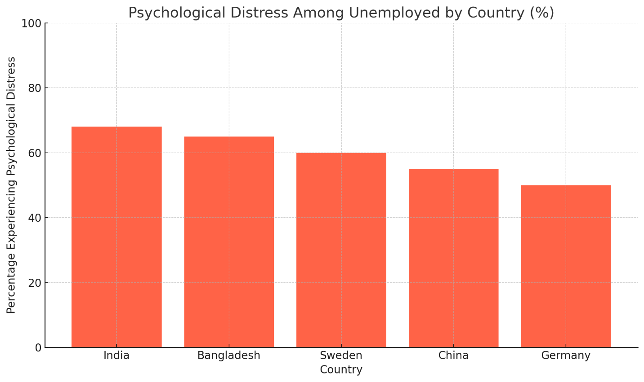

**Insight:** India reports the highest rate of distress (68%), revealing the urgent need for integrated policy solutions. Despite economic growth, the absence of public mental health infrastructure worsens outcomes

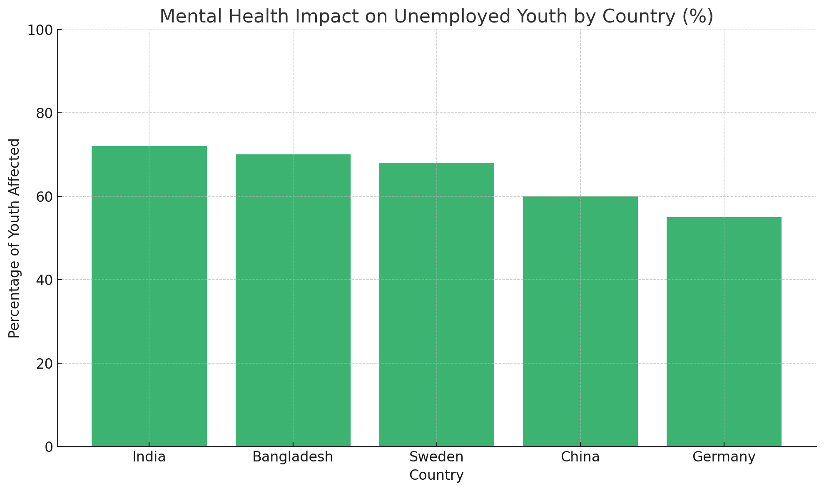

**Insight:** Youth in Bangladesh and India are significantly more affected than those in developed nations. The emotional fallout is closely tied to **economic precarity, lack of guidance**, and **social pressures** around success and productivity.

**Discussion**

Unemployment is not merely an economic indicator—it is a psychological stressor with far-reaching emotional, cognitive, and social consequences. This study reveals that **joblessness affects individuals on multiple psychological dimensions**, including self-esteem, identity, motivation, and social belonging. These effects are more pronounced in countries like **India**, where the absence of strong social security, coupled with intense societal pressure and stigma surrounding mental illness, exacerbates mental health challenges.

**1. Emotional Consequences of Job Loss**

Findings from both global and Indian datasets indicate that the unemployed are significantly more prone to experience:

* **Depression and anxiety disorders**
* **Loss of purpose and social detachment**
* **Heightened risk of substance abuse and suicidal ideation**

This emotional toll results not only from financial instability but also from **loss of structure, status, and social validation**, as proposed in Jahoda’s Latent Deprivation Theory. The **identity-shaping role of employment** is particularly critical for youth and male breadwinners in patriarchal societies, where unemployment is perceived as personal failure.

**2. Cultural and Structural Stigma in India**

India’s mental health challenges are compounded by **deep-rooted stigma**, which prevents early intervention. Unemployed individuals often:

* Avoid seeking help due to fear of being labeled "mad" or "weak"
* Internalize guilt, leading to **learned helplessness**
* Receive minimal emotional support due to family and community denial

The **National Mental Health Survey (2016)** showed that **only 1 in 10 people with depression receive treatment**, and this is even lower among unemployed individuals who lack resources and exposure to mental health education.

**3. Gendered Impact and Youth Vulnerability**

* **Young adults (18–30)** face a crisis of expectations. A mismatch between education and employment opportunities leads to **emotional paralysis**, especially in urban job-seekers.
* **Women**, especially in rural and semi-urban India, experience joblessness as a form of **economic and emotional invisibility**. Many are discouraged from working at all, and when unemployed, they face dual stigma—gender-based and mental health-based.

The intersection of gender, age, and employment status reveals that mental health outcomes are **not evenly distributed** but concentrated among **socially vulnerable** demographics

**4. Policy Disconnect**

India’s employment and mental health policies operate in **silos**. Employment programs (e.g., **Skill India**, **NULM**) focus on technical skilling without considering the **emotional strain** of joblessness. Mental health services (e.g., **Tele MANAS**, **District Mental Health Programme**) are underfunded, poorly staffed, and disconnected from job market realities.

In contrast, countries like **Germany** and **Sweden** integrate employment assistance with psychological counseling and benefit programs. Even during COVID-19, governments in these nations **proactively communicated emotional support**, recognizing that **economic distress and emotional trauma are inseparable**.

**5. Digital Potential and the Road Ahead**

India’s growing digital infrastructure offers a **transformative opportunity** to connect job-seekers with mental health support via:

* **Mobile-based therapy** in vernacular languages
* **AI chatbots for anonymous emotional support**
* **Integrated job counseling and mental health platforms**

However, **technological interventions must be embedded in policy** and supported with awareness campaigns, school-to-work transition support, and **community-based sensitization programs**.

**Limitations**

While this study offers significant insights into the relationship between unemployment and mental health across international and Indian contexts, several limitations must be acknowledged to frame the interpretation of results and implications accurately.

**1.Limited Access to Updated Indian Mental Health Data**

Although national-level datasets such as the **National Mental Health Survey (2016)** and **CMIE’s Unemployment Reports** are used, **post-pandemic primary data in India is limited or outdated**. The psychological landscape has likely changed post-COVID, but a lack of rigorous follow-up surveys restricts understanding of the evolving unemployment-mental health nexus.

**2. Self-Reported Bias and Stigma**

Mental health data—especially in low- and middle-income countries like India—relies heavily on **self-reporting**, which is influenced by **social desirability bias and stigma**. Individuals, especially men and those in rural areas, may underreport mental distress due to cultural taboos or fear of social exclusion.

**3. Cross-Cultural Contextual Differences**

The global comparison (Germany, China, Bangladesh, Sweden) introduces **variability in socio-political environments**, healthcare systems, and cultural perceptions of work and well-being. Therefore, findings may not always be directly comparable or generalizable across regions, even with thematic synthesis.

**4. Underrepresentation of Marginalized Groups**

This study did not sufficiently capture the mental health experiences of:

* **Persons with disabilities**
* **Informal and migrant workers** These groups often face **dual or triple marginalization**, where unemployment intersects with identity-based discrimination—an area requiring deeper exploration.

**5. Absence of Longitudinal Analysis**

Most data reviewed is **cross-sectional**, capturing snapshots of mental health during unemployment but not tracking **long-term psychological trajectories**. Understanding how prolonged or cyclical unemployment affects mental resilience, coping, or recovery would benefit from longitudinal studies.

**6. Urban-Centric Data Bias**

Much of the available data, particularly from online and published studies, overrepresents **urban populations**. Mental health consequences in **remote rural or tribal areas**, where awareness and access to services are critically low, remain **understudied**.

**7. Limited Policy Evaluation Metrics**

While the study critiques and compares policies across nations, it lacks **empirical evaluation** of the actual success or failure of specific interventions (e.g., Tele-MANAS, Skill India, youth employment schemes) due to the absence of granular impact data.

**Conclusion**

Unemployment deeply affects mental health, leading to increased anxiety, depression, and emotional distress—especially among youth, women, and rural populations. This study highlights that while countries like Germany and Sweden offer psychological support with job loss, India faces a dual crisis: **rising unemployment and inadequate mental health care**.

To move forward, India must **integrate mental health support into employment programs**, expand community outreach, and destigmatize mental health issues. Without addressing the emotional toll of joblessness, economic growth alone cannot ensure national well-being.

Unemployment is not just a lack of income—it’s a **loss of identity, purpose, and mental stability**. Solving it requires both jobs and healing.

**Recommendations**

Based on the findings and analysis, the following actionable recommendations are proposed to address the mental health impacts of unemployment:

**1. Integrate Mental Health into Employment Programs**

Employment initiatives like **Skill India**, **Startup India**, and **MUDRA** should include mental health support services such as counseling, stress management workshops, and emotional resilience training.

**2. Strengthen Community-Based Mental Health Outreach**

Develop and expand **district-level mental health programs**, especially in rural and semi-urban areas, using tele-counseling, mobile clinics, and trained community health workers.

**3. Promote Early Intervention Among Youth**

Introduce **mental health education and career counseling** in schools, colleges, and job-skilling centers to help young people cope with failure, uncertainty, and career anxiety.

**4. Launch National Awareness and Destigmatization Campaigns**

Use mass media, social media, and local influencers to normalize discussions about **unemployment-related mental health issues**, especially among men and marginalized groups.

**5. Collaborate with NGOs and Mental Health Startups**

Encourage partnerships with organizations like iCall, Sangath, and YourDOST to provide **affordable and scalable mental health support** for unemployed individuals.

**6. Develop Inclusive Policies**

Ensure that mental health policies and employment schemes are sensitive to **gender, LGBTQ+, and disability-related challenges**, offering tailored psychological support where needed.

**7. Invest in Research and Real-Time Data Monitoring**

Regularly update national mental health and unemployment data to guide timely interventions. Support **longitudinal studies** to track the long-term effects of unemployment on mental health.

**References**

1. Buecker, S., et al. (2021). Psychological Distress and Unemployment.
2. Liu, Y., et al. (2024). Public Mental Health via Weibo in China.
3. Rahman, M. M., & Hossain, M. M. (2022). Graduate Depression in Bangladesh.
4. Bartelink, V., et al. (2020). Youth Depression in Sweden.
5. CMIE (2023). Employment & Unemployment in India.
6. NMHS (2016). National Mental Health Survey.
7. WHO (2023). Mental Health and Employment Toolkit.
8. Sen, A. (1993). Development as Freedom.